Project Design Phase-II
Technology Stack (Architecture & Stack)

Date | 11 July 2026
Team ID
Project Name | shopEZ-MERN E-commerce Application
Maximum Marks | 4 Marks

Technical Architecture:
The Deliverable shall include the architectural diagram as below and the information as per the table1 & table 2

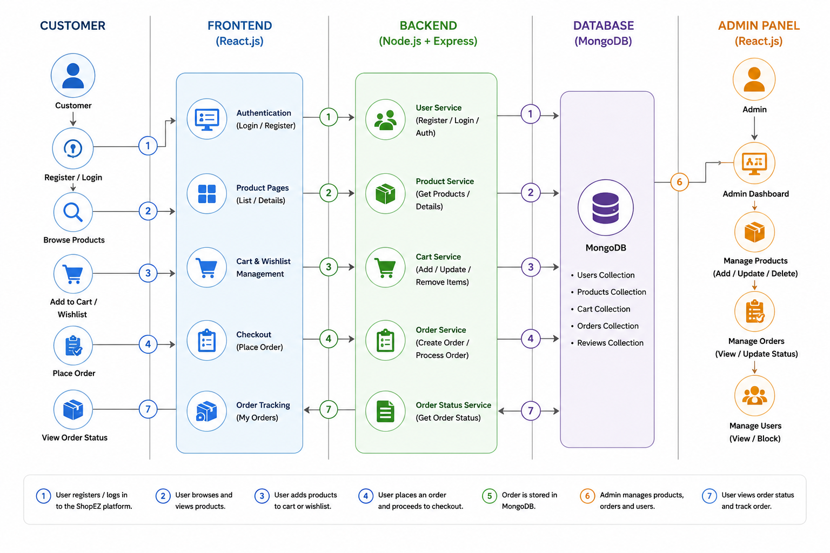
Table-1 : Components & Technologies:
S.No | Component | Description | Technology
 | User Interface | Web interface for customers and administrators to browse products, manage cart, wishlist, and orders | React.js, HTML, CSS, JavaScript, React Router
 | Application Logic-1 | User Authentication,Authorization,product,category,cart,wishlist | Node.js, Express.js
 | Application Logic-2 | Restful API’S,JWT,middlewares,Business Logic | Express.js, JWT, Bcrypt.js
 | Application Logic-3 | Admin Dashboard, Order Status Management, Payment Handling (COD), Validation | Node.js, Express.js
 | Database | Stores Users, Products, Categories, Cart, Wishlist, Orders, Payments | MongoDB (NoSQL), Mongoose ODM
 | Cloud Database | Database Service on Cloud | MongoDB Atlas
 | File Storage | stores image URL’s | Atlas
 | External API-1 | REST API communication between frontend and backend | Axios HTTP Client
 | External API-2 | N/A | N/A
 | Machine Learning Model | N/A | N/A
 | Infrastructure (Server / Cloud) | MERN application deployed on local development environment | Frontend: React (Vite)  Backend: Node.js + Express  Database: MongoDB Community Server  Deployment: Localhost (Future: Render/Vercel)

Table-2: Application Characteristics:
S.No | Characteristics | Description | Technology
 | Open-Source Frameworks | The application is built using open-source frameworks for frontend, backend, routing, and database operations. | React.js, Node.js, Express.js, MongoDB, Mongoose, React Router, Axios
 | Security Implementations | User passwords are securely hashed, authentication is handled using JWT, APIs are protected with role-based authorization, and passwords are never stored in plain text. | JWT, bcrypt.js, Role-Based Access Control (RBAC), CORS, Environment Variables (.env)
 | Scalable Architecture | The application follows a 3-tier architecture with separate frontend, backend, and database layers, making it easy to maintain and scale | React.js + Express.js + MongoDB
 | Availability | The cloud-hosted database is highly available, and the application can be deployed on cloud platforms for continuous access. | MongoDB , Node.js Server
 | Performance | REST API’s provide efficient data access | MongoDB Indexing, React.js, Axios, Express.js

